 | Pipsico Scout Reservation  Camp Staff Application | 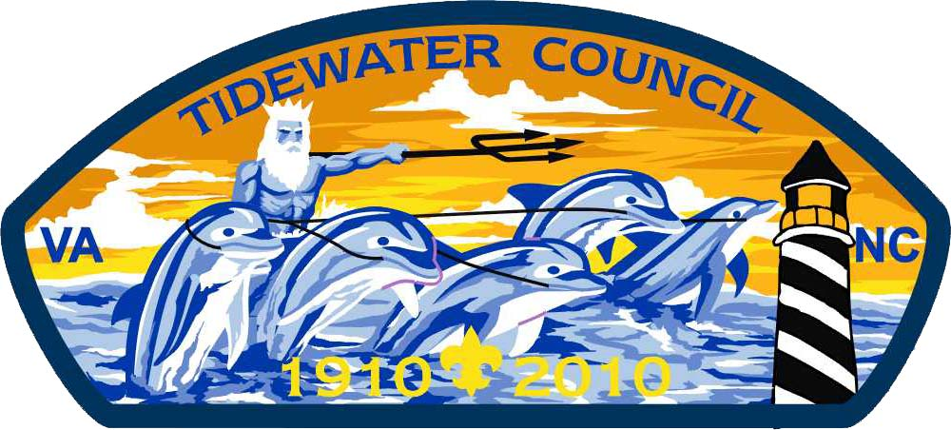

Personal Information
Name:
 | First |  | Middle |  | Last |  | Suffix

Address:
 | Street |  | City |  | State |  | Zip

Other:
 | Home Phone |  | Mobile Phone |  | Email

Highest Level of Education: |  |  |  | Major/Degree/Certificate:
School: |  |  |  | GPA:

Under 16 | 16-17 | 18-20 | 21+ |  |  |  |  |  | yes | no
Age as of June 1st before camp |  |  |  |  | T-Shirt Size |  | Occupation |  | Legally Employable in US

If military, would take: | Leave |  | Permissive TDY |  | Both

Scouting Experience
None: | ☐ | Scouting experience is NOT a requirement for employment.
Currently registered as: |  |  | Unit & #: |  | Council:
 |  | Position

Have you ever served on resident camp staff (including CIT)?
Camp |  | Year |  | Position(s)

 |  |  |  | Yes | No | Lapsed |  | Ordeal | Brotherhood | Vigil
Highest Rank Attained |  | Offices Held |  | OA Member |  |  |  | OA Honor Level

How many times have you attended a BSA Summer Camp? |  |  |  |  |  | How many different camps?
Number days & nights of outdoor camping experience (circle): |  |  |  | 0 – 20 |  | 21 – 50 | 51 – 100 |  |  | 100+
I have participated in:
☐ | National/World Jamboree | ☐ | Day Camp Staff | ☐ | Youth Protection |  |  | ☐ | Weather Hazards
☐ | Florida Sea Base | ☐ | District Camporee Staff | ☐ | Woodbadge |  |  | ☐ | IOLS
☐ | Northern Tier | ☐ | Council Camporee Staff | ☐ | NYLT |  |  | ☐ | WOLS
☐ | OA High Adventure | ☐ | Conclave Staff | ☐ | Den Chief Training |  |  | ☐
☐ | Philmont | ☐ | Woodbadge/NYLT Staff | ☐ | Leader Specific Training |  |  | ☐

BSA National Camping School Session: |  |  |  |  | Expiration Date:
American Red Cross Certifications:
EMT or Advanced First Aid Certification: |  |  |  | CPR cert thru 8/20/11: |  |  | Yes | No

Self-Evaluation
Give a fair evaluation of your talents and skills in the following areas:
X = |  | Have some experience or have earned related merit badge
XX = |  | Have extensive knowledge & skill
XXX = |  | Have taught
 | Acting/Drama |  |  | First Aid |  | Musical Instruments
 | Archaeology |  |  | Fish & Wildlife Mgmt. |  | Orienteering
 | Archery |  |  | Fishing |  | Rifle Shooting
 | Astronomy |  |  | Food Service / Mass Feeding |  | SCUBA
 | Backpacking |  |  | Forestry |  | Selling / Marketing
 | Basketry |  |  | Handicapped Awareness |  | Signing for the Deaf
 | Camping |  |  | Health & Sanitation |  | Small Boat Sailing
 | Canoeing/ Rowing |  |  | History of Colonial America |  | Snorkeling
 | Climbing & Rappelling |  |  | Indian Lore |  | Soil & Water Conservation
 | Cooking |  |  | Inventory Control |  | Song Leading
 | CPR |  |  | Knots, Lashing & Splicing |  | Sports
 | Creative Writing |  |  | Leadership |  | Supervision of People
 | Cycling |  |  | Leading Worship Services |  | Swimming & Lifesaving
 | Dishwashing |  |  | Leatherwork |  | Teaching
 | Emergency Preparedness |  |  | Mammal Study |  | Wilderness Survival
 | Environmental Science |  |  | Metal Work |  | Woodcarving

Give additional details of your experiences, education or training, which may be helpful to us:

Position(s) Applied For
Please indicate 1st, 2nd and 3rd choice. MINIMUM AGE for paid staff positions is 16:
 | Counselors |  | Directors |  | Other
 | Archery• |  | Program Director  |  | Business Manager •
 | Boating/Skiing/Wakeboarding• |  | Scoutmaster Program Director  |  | Commissioner 
 | Canoeing +/or Rowing |  | Aquatics Director  |  | Quartermaster
 | Climbing |  | Climbing Director  |  | Health & Safety Officer 
 | Fishing |  | Handicraft Director |  | Chaplain 
 | Handicraft |  | High Adventure Director  |  | Head Cook•
 | High Adventure |  | Huskanaw Director |  | Assistant Cook•
 | Huskanaw |  | Natural History Director  |  | Dining Hall Steward•
 | Natural History |  | Nature Director |  | Dining Hall Staff
 | Nature |  | Pool Director • |  | Trading Post Clerk
 | Rifle +/or Shotgun |  | Scoutcraft Director |  | Trading Post Manager•
 | Scoutcraft |  | Shooting Sports Director 
 | Sm. +/or Lg. Boat Sailing |  | Waterfront Director •
 | Swimming +/or Lifesaving
• Minimum Age 18  Minimum Age 21  BSA Camp School required

New applicants. Answer the following question. Why do you want to be on Camp Staff?

Other Information
Describe your hobbies & special interests:
Describe any military service/experience:
Have you ever been convicted of a felony? |  |  | Yes | No | Misdemeanor? | Yes | No
If yes, explain:

Employment
Company/Employer |  |  | Position Held |  | Dates |  |  | Supervisor |  |  |  | Phone
Have you ever been discharged or asked to resign from any job? |  |  |  |  |  | Yes |  |  | No
If yes, why?

References
 | Name |  | Phone |  | Association
Scouting
School
Employer
Other

Availibility/Compensation
I am available /interested in working: (circle)
 | Base Camp: |  | Staff Week |  | Boy Scouts | Cub Scouts |  |  | Close-out
-or-
 | James River Adventure Base: |  | Staff Week |  | Canoe Trek |  |  | Cub Scouts |  | Close-out
 | (Select specialty) |  |  |  | Fish Camp
 |  |  |  |  | James River Adventure
 |  |  |  |  | John Smith Program
 |  |  |  |  | Sail Hampton Roads
-or-
List Dates/Explain:
Seeking Compensation Via: |  | Money |  | Community Service Hours |  |  | Internship Credit |  |  |  | Thank You Letter

I certify that the above information is true and accurate to the best of my knowledge. I understand that, if employed, I serve at the discretion of the Camp Director and may be relieved of any responsibilities at any time based on camp attendance, health, personal behavior, or other unforeseen circumstances.

SIGNATURE OF APPLICANT: |  | Date:

All applicants under 18 years of age must have this application signed by a parent/guardian and unit leader. Applications cannot be accepted without these signatures.

Signature of Parent/Guardian |  | Date |  | Signature of Unit Leader |  | Date

Parent e-mail address(s): ______________________________________________________________________________

FOR OFFICIAL | Date received: |  | Date Interviewed: | ___ Accepted ___ Rejected
USE ONLY | Hired as: |  | Salary: | Date notified:

