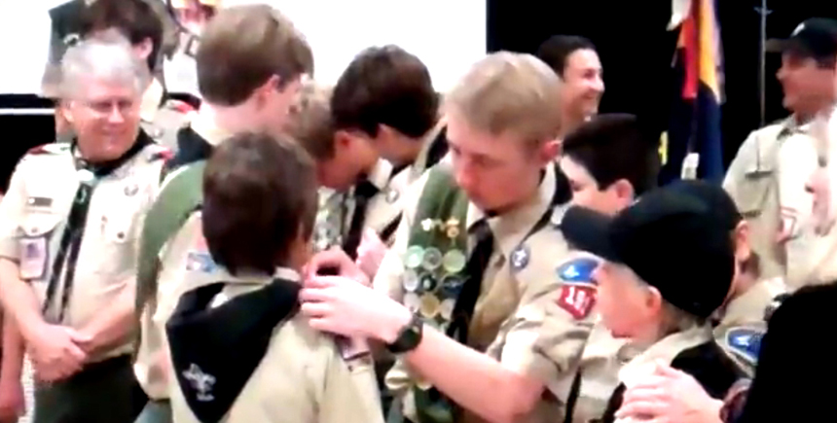
Transitioning Webelos to Boy Scouts is the most effective approach to growing or maintaining Troop membership. The process is more involved than simply welcoming Webelos from your sister Pack to the troop. An effective transition does several very important things that not only attract Webelos and parent to your troop but set them up to stay in the troop. Done right a transition will:
- Help Webelos and their families find a troop whose character and size best fits their needs
- Sells Webelos on the exciting opportunities they will have in Boy Scouts
- Sells parents on the value of continuing in Scouting
- Provides a complete orientation and assists Webelos and their families in settling into a Troop
- Provides exciting activates immediately after crossover to seal the deal
The sections below describe the transition roles and responsibilities for the pack, troop, and district. And the last section contains a few crossover ceremonies to help you make the transition a memorable experience both the Webelos and their families.

Pack Responsibilities
It should be the goal of the Cubmaster and Webelos den leaders to graduate every Webelos Scout into a Boy Scout troop. The key to accomplishing this is to begin promoting Boy Scouting when Cub Scouts are still in their Tiger, Wolf, and Bear dens, and to sell the sizzle of the great outdoors. Scouting should be viewed as an ongoing adventure, and the progression should be as normal as moving from elementary school to middle school.
- Develop a working relationship with the leadership of a Boy Scout troop or troops in the community. Most troops should have either an assistant Scoutmaster or a committee member assigned to new Scouts. Your unit commissioner can help put you in contact with troop leaders.
- Compare calendars of troop and pack activities to coordinate activities. Community events can be done together, and planning can help prevent conflicts in use of equipment and facilities.
- Work with troop leaders to secure den chiefs for each Webelos den and Cub Scout den.
- Work with troop leaders to plan and conduct Webelos overnight activities.
- Den Leaders work with troop leaders to plan visits to troop meetings. Never show up without first calling in advance. Webelos dens should visit more than one troop so Webelos and parents can find the troop with the right character and size to meet their needs.
- Invite the Scoutmaster and troop youth leaders to special pack activities. This will help create familiarity and a level of comfort for the Webelos Scouts and their parents as they ease into the troop.
- Plan a meaningful crossover ceremony at the pack’s blue and gold banquet. Include troop leadership to be present to accept the Webelos Scouts as they graduate to Boy Scouting. The local Order of the Arrow lodge can often be a valuable resource in conducting ceremonies.
- Webelos leaders should be strongly encouraged to move into the troop with the boys, either as assistant Scoutmasters or troop committee members. This will give the new Scouts a familiar face at troop meetings and a connecting link to Boy Scouting.
- If a troop does not exist in your community, discuss with the head of the pack’s chartered organization the possibility of organizing a troop. A graduating Webelos den can form the nucleus of a new troop.

Troop Responsibilities
Boy Scout troops should assign an assistant Scoutmaster or a troop committee member to be responsible for new Scouts, which would include developing a relationship with the Cubmaster and the Webelos den leaders. This person serves as a resource during Webelos overnight activities and builds enthusiasm among boys and their parents for the exciting challenges that await them in Boy Scouting.
- Select Scouts to serve as den chiefs for each Webelos Scout den and Cub Scout den. Arrange for Den Chief Training.
- Serve as a resource for overnight activities. The troop can be of service to provide equipment, leadership, and logistics for Webelos parent-son campouts.
- Conduct an orientation in the Bear Cub Scout dens to explain the changing role as boys become Webelos Scouts and then again as they become Boy Scouts. Explain how being a Webelos Scout will help prepare them for Boy Scouting.
- Webelos den/Scout troop campouts should show Webelos Scouts and their parents what to expect when they move into the troop. The troop should cook and camp by patrol, and use skills that the Webelos Scouts can participate in.
- Arrange for Webelos dens to visit a troop meeting. This should be planned several weeks in advance.
- Provide each Webelos Scout a copy of the troop’s activities for the upcoming year.
- Work with Webelos den leaders to encourage them to plan to move into the troop with their Webelos Scouts and to serve either as committee members or assistant Scoutmasters.
- Conduct a Scoutmaster conference under the guidance of the Scoutmaster or the assistant designated by the Scoutmaster. This conference should cover the meaning of the Scout Oath and Law, the advancement program, troop camping, the patrol method, summer camp, and personal equipment.
- Work with the Cubmaster in planning a meaningful crossover ceremony at the pack’s blue and gold banquet. Coordinate the ceremony and arrange for each Webelos Scout to receive a troop neckerchief and Boy Scout Handbook along with his Arrow of Light Award. Members of the Order of the Arrow may assist in the ceremony.

Unit Commissioner Responsibilities
The unit commissioner is the connecting link in the chain between the troop and the pack. Often, the same unit commissioner will serve both a pack and troop in the same community
- Be a catalyst in developing good relationships between troop and pack leaders.
- Promote communication by scheduling a meeting of key volunteers.
- Help plan a Webelos den visit to a troop meeting and other joint activities.
- Keep the pack and troop on schedule as plans develop for the crossover ceremony at the blue and gold banquet.
- Attend the crossover ceremony.
- Be sure new Scouts have completed a Boy Scout application, that they have a copy of the troop’s activities, and that they know when and where the troop meets.
- Work with the pack and troop in their charter renewal process to help ensure Webelos Scouts are moved from pack rosters to troop rosters.
- Work with the Webelos transition chair to follow up on boys who have not yet joined a troop. Make sure they are invited to join a troop.
- Be sure Webelos Scouts join a troop in time to prepare for Boy Scout summer camp.

District Webelos Transition Chair Responsibilities
A key person to successful Webelos graduation is the district Webelos Transition Chair. This person is a member of the district membership committee and is charged with making sure every Webelos Scout is given an opportunity to join a troop.
- Contact all packs in early fall to update a list of all fifth-grade Webelos Scouts.
- Coach Cubmasters and Webelos den leaders in the transition process at roundtables, training courses, and through personal contact.
- Report to the membership committee chair, and keep the district committee informed.
- Track and maintain records of Webelos graduation by using a wall chart that lists the transition record of each pack.
- Work with unit commissioners to follow up on Webelos Scouts who have not joined a troop.
- Work toward 100 percent Webelos transition.

Ceremonies
Members of the troop frequently participate in a Webelos-to-Scout ceremony, even when it is formally conducted by the Cub Scout Pack. During these occasions the troop’s participation greatly contributes to the overall crossover experience. When Webelos are being recognized, frequently they cross a symbolic bridge from the pack to a troop. The troop’s presence should be as impressive as possible. In this light, for most crossover ceremonies, there should be a good assemblage of Scouts in attendance, wearing their most complete troop meeting field uniforms. Naturally, if a troop neckerchief is to be presented, the troop members should be wearing theirs, and as always, Scout spirit should shine brightly throughout the proceedings.
The Bridge
Crossing a bridge from a Cub Scout Pack to a Boy Scout Troop is a symbolic act. If there’s no actual bridge, most packs build or borrow a simple, portable, wooden one that’s rustic with railings made of dead tree branches or rope, and floored with scrap lumber.
What’s Presented During the Crossover
Since with each level in the pack there’s been a corresponding neckerchief, if the troop has a troop neckerchief, presenting one to each Webelos Scout crossing over is an appropriate symbolic gesture. The Webelos neckerchief is removed, and the pre-folded troop neckerchief is placed around the Webelos’ neck, either with the same slide or with one provided by the troop. Doing so, ceremoniously, with the friendly participation of assigned troop leaders creates a memorable moment. In conjunction with this, exchanging the blue shoulder loops with olive green shoulder loops provides added impact. A Boy Scout Handbook as well as the troop’s unit numeral (if different than that of the pack’s) can also be presented at this time.
Outdoor Ceremonies
Perhaps the most impressive of all Webelos crossover settings is one where the troop is gathered around a lit campfire in an area distinct from, but in view of, where the pack has gathered. Optimally, there is an actual bridge separating the pack and troop locations. After the Cubmaster addresses the Pack family and turns things over to the leader of the Webelos Den for his explanations and remarks, the Senior Patrol Leader from the troop, along with at least two other junior leaders, escort the appropriate Webelos Scouts (often with their parents) over the bridge, to the troop’s campfire, which has been lit in their honor. Once over the bridge, the Scoutmaster and troop leaders greet the Webelos who join the troop’s members seated around the fire. At that time, a new member investiture ceremony can commence.
Simple Crossing The Bridge Ceremony
In attendance are the Webelos den leader, Scoutmaster, Scouts representing the troop, graduating Webelos Scout(s) and parents. The bridge is placed up front, house lights are dimmed, and a bright LED flashlight directs its beam on each end. The Webelos den leader, with the graduating Webelos Scout(s) and parents, stand on one end of the bridge. On the other end is the Scoutmaster and troop representatives holding a rolled troop neckerchief(s).
– Webelos Den Leader: During the years you have been in Cub Scouting, we have had numerous opportunities to work together along the trail. Now [name(s) Webelos Scout(s)] is leaving the pack to enter Boy Scouting where I am sure you are going to make many new discoveries and experience a wide variety of new adventures.
– To symbolize your growth and entrance into Boy Scouting, your Webelos Scout neckerchief will now be removed. (Neckerchief(s) removed and handed to parents.) Now, please carefully cross over the bridge into Boy Scouting, and be welcomed by the Scoutmaster of Troop (number).
– Scoutmaster: (Greets Webelos Scout with the Boy Scout handshake.)As Scoutmaster of Troop (number), it is indeed a pleasure for me to welcome you into the troop. We meet each week at (time) at (place). We shall look forward to seeing you at our next meeting.
And now I present to you this Boy Scout neckerchief (Rolled neckerchief is placed around the Webelos neck.) May you wear it with pride. It’s colors are those of Troop (number), which welcomes you as its newest member(s).
Simple Pack Gathering Crossover Ceremony
– Invited are the Scoutmaster, an Assistant Scoutmaster, and the Senior Patrol Leader. The crossover bridge that the graduating Webelos Scouts can walk across from the left side to the right side is situated up front. The Cubmaster and Assistant Cubmaster stand on the left side of the bridge. The troop representatives are called up and stand on the right side of the bridge.
– The first Webelos Scout with his parents is asked to come forward. The parents stand to the left of the Cubmaster and the Webelos Scout stands with his back to the bridge.
– The Cubmaster turns to the Webelos Scout and silently removes his hat, and hands it to the Assistant Cubmaster to hold upside down. In turn, the following items are removed and placed in the hat: neckerchief slide, neckerchief, blue shoulder loops.
– The Assistant Cubmaster then hands the hat to the Webelos Scout’s parents. The Cubmaster shakes their hands and sends the parents in front of the bridge to the other side to stand with the troop representatives.
– The Cubmaster and Assistant Cubmaster both shake hands with the Webelos Scout, first with the Cub Scout handshake, and then with the Boy Scout handshake. The Webelos Scout then turns to face the bridge and crosses over.
– On the other side, the Scoutmaster, Assistant Scoutmaster, and Senior Patrol Leader put on olive green shoulder loops, and a troop neckerchief (if the troop uses one). Other items can be presented at this time as well.
– After each graduating Webelos Scout crosses over, all the remaining Cub Scouts and attendees are instructed to stand and salute the new Boy Scouts as they file out to form a receiving line at the back of the room, from where they can greet everyone before refreshments are served.
Rudyard Kipling Crossover Ceremony
Akela’s lines can easily be divided between the Cubmaster, Assistant Cubmaster, Webelos Den Leader, and Assistant Webelos Den Leader.
– Akela: The moon is full, just as it was long ago on that night in the jungle when Mowgli first joined the wolf pack. It has been many years since Mowgli returned from living with the wolves. After he returned, he taught us many of the lessons he learned while in the jungle. The most important was that the strength of the wolf is the pack, and the strength of the pack is the wolf.
– That is why we are here tonight in this council ring. But just as Mowgli had to leave the pack, tonight we also have some man cubs among us who have grown strong and tall. The time has now come when they too must leave the pack to find their place in the world of men.
– They have learned many lessons as they have walked the trails of the bobcat, tiger, wolf, and bear. Tonight, these cubs are ready to begin their next adventure on their way to manhood. We will not hold them back, though we will miss them when they are gone. Instead, we will wish them well and send them into the wild where they will continue on their path.
– So let us begin. Parents, bring forward these man cubs. (Akela calls out the names of the Cubs who will be crossing over. Parents and Cubs come forward and face the rest of the pack.) Akela of men, do you hear me?
– Senior Patrol Leader: I hear you, Akela of the man cubs. What is it that you want?
– Akela: We have among us several Webelos Scouts who have grown tall in body and strong in character. They have learned well the ways of the pack, but now they yearn to run with older Scouts in the wild places. They have been with the pack for many moons, and have been a source of pride for us all. But now it is time that they must leave us and search out greater adventure.
– Senior Patrol Leader: I understand you and I will accept them into my tribe and guide them in those wild places. (Akela now leads the Webelos, one at a time, to the bridge between Cub Scouts and Boy Scouts. After the Webelos neckerchief and blue shoulder loops are removed, they cross the bridge to troop members waiting with Scout handbooks, troop neckerchiefs, and green shoulder loops.)
– Akela: These Webelos Scouts are no longer with our pack, yet we still call on the Great Akela of all Cub Scouts and Boy Scouts to always guide their way. We ask that the Great Akela watch over them as they learn to soar with Eagles in the wild places. And, in the fullness of time, we pray that these boys will return, tall and proud and strong, and present their own man cubs to be accepted into the pack. But until then, let us send them on their way with a mighty wolf howl.

Sunset Crossover Ceremony at Triple R Ranch
See set up notes and layout diagram after the ceremony script. This script is tailored for Triple R Ranch but will work at any location that allows open fires and has enough room for the ceremony ring and spectators.
Spectators set up seating outside the ceremonial ring facing the lake (North) with the road to the left (West). Akela staged out of site stage right (East). See picture in set up notes.
Akela is an adult dressed in Indian garb. This adult MUST be able to memorize the script.
Call to be seated 20 minutes before sunset.
15 minutes before sunset Drum begins.
Webelos are staged outside the fire ring behind the spectators. When the drum starts all pass by Indian2 at start of walkway to ceremony ring. Webelos say password "Be Prepared" to Indian2. All Webelos remain silent thereafter until asked to respond during the ceremony.
Webelos form in dens outside the ceremonial ring with Den Leaders stage right who are in place before the Webelos start walk to ceremony ring.
Whan all Webelos are in place drum stops and Cubmaster steps up to position inside the torch ring.
Indians present Cubmaster with a rope and three staves/branches (see setup notes).
Cubmaster: Holds up rope. "This piece of rope represents the Cub Scout program…a program specifically designed for you and your parents. A program filled with service projects, outdoor games and lifelong experiences, and loads of fun."
Cubmaster: Ties rope to first staff. "The first staff represents you, the Scout, a boy seeking the path to manhood. The rope is tied to the staff because the program supports the boy on his journey. But the program is not enough. Demonstrates that staff would fall if left standing alone. Just like this staff, if left with just the Scout program, would you Webelos Scouts be able to stand alone?"
Webelos Scouts: "No."
Cubmaster: Picks up second staff. “The second staff represents the Pack and the Troop. Your Patrol Leaders, Cubmaster, Scoutmaster, and all the other Scouters who work in the Scouting program. The Scout program binds together the scout and his supporters.” Ties second staff to first. Demonstrates that both staves would fall if left standing alone. “But the 2 staves and the rope are not enough. Den Leaders, if left just with your Scout and the program, would you be able to stand alone?"
Den Leaders: "No."
Cubmaster: Picks up third staff. "The third and final staff represents the parents; the support, help, and guidance behind every Cub Scout. When added to these two staves, we see a Cub Scout can stand and walk the trail of Akela." Ties third staff to first. Stands tripod up near fire ring. Demonstrates that three staves stand solidly without any other support. "If any one of these staves is pulled away, the other two would fall. Parents, if you pull away from Scouts, would your son be able to walk alone along the Path of Akela?"
Parents: "No."
Cubmaster: Faces spectators. "The strength of the rope comes from its strands. The strength of the Cub Scout program comes from its strands: the Cub Scout promise, Law of the Pack, and motto. Webelo Scouts, do you promise to continue to live by and never forget the Cub Scout promise, Law of the Pack, and Cub Scout motto?"
Webelo Scouts: "Yes."
Cubmaster: "Patrol Leaders, do you promise to continue to help support these Cub Scouts and their Parents as they move into Boy Scouts?"
Patrol Leaders: "Yes."
Cubmaster: "Parents, do you promise to continue to provide guidance and wisdom to your son, to help support his Patrol, and actively take part in his Troop?"
Parents: "Yes."
Cubmaster: "It is with great pleasure that I congratulate you on your success following Akela's trail to Cub Scout's highest honor, the Arrow of Light. May your trek along the trail to Eagle Scout be as successful -- and as enjoyable -- as your journey through Cub Scouts."
Drum begins and Indian1 moves to left of fire ring and raises 2-finger Cub Scout Sign.
Indian2 moves to right of fire ring and raises 3-finger Scout sign. Drum stops.
Indian2: "Welcome to our council fire. Tonight we will honor these Webelos for their persistence in reaching the end of the Cub Scout path. We are pleased with this accomplishment. With this honor they have earned the right to pass from Cub Scouting to Boy Scouting. As a symbol of this passage, my brother (Indian1) held up three fingers -- the Scout sign.
Indian1: The three fingers stand for: Duty to God & country, duty to others, and duty to self. Please join me in the Boy Scout oath." All give the sign and recite the oath.
Indian 2: Holds up bow over his head. "Using this symbol of Scouting we will summon the Great Akela, the leader of the Cub Scouts to carry on the rest ceremony."
Indian1 passes bow over head with arrow to Indian2. Sparklers lighted (see setup notes).
Indian2: "On my honor…country." Shoots arrow into lake
Indian2 passes bow over head with arrow to Indian1. Sparklers lighted.
Indian1: "To obey…time." Shoots arrow into lake
Indian1 passes bow over head with arrow to Indian2. Sparklers lighted.
Indian2: "To keep…straight." Shoots arrow into lake. Raises arms and bow…"Great Akela -- please join our council fire. It is your time."
Akela lights torch. Indians 1 & 2 move to either side of tiki torches in preparation to light.
Akela calls out 12 points of the Scout Law he walks toward the fire from stage right. As each point is called out, Indians light a tiki torch (see setup notes) and Cubmaster explains meaning of each point of Law.
Akela: "A Scout is Trustworthy."
Cubmaster: "A Scout tells the truth. He keeps his promises. Honesty is a part of his code of conduct. People can always depend on him."
Akela: "A Scout is Loyal."
Cubmaster: "A Scout is true to his family, friends, Scout leaders, community, nation, and world community."
Akela: "A Scout is Helpful."
Cubmaster: "A Scout is concerned about other people. He willingly volunteers to help others without expecting payment or reward."
Akela: "A Scout is Helpful."
Cubmaster: "A Scout is concerned about other people. He willingly volunteers to help others without expecting payment or reward."
Akela: "A Scout is Friendly."
Cubmaster: "A Scout Friend to all and a brother to other Scouts. He seeks to understand others. He respects those with ideas and customs different from his own."
Akela: "A Scout is Courteous."
Cubmaster: "A Scout is polite to everyone regardless of age or position. He knows that good manners help people get along."
Akela: "A Scout is Kind."
Cubmaster: "A Scout understands there is strength in being gentle. He treats others as he wants to be treated. He does not harm or kill anything without good reason."
Akela: "A Scout is Obedient."
Cubmaster: "A Scout follows the rules of his family, school, and troop. He obeys the laws of his community and country. If he thinks these rules or laws are unfair, he tries to have them changed in an orderly manner rather than disobey them."
Akela: "A Scout is Cheerful."
Cubmaster: "A Scout looks for the bright side of life. He cheerfully does tasks that come his way. He tries to make others happy."
Akela: "A Scout is Thrifty."
Cubmaster: "A Scout works to pay his way and to help others. He saves for the future and protects and conserves natural resources. He carefully uses time and property."
Akela: "A Scout is Brave."
Cubmaster: "A Scout can face danger if he is afraid. He has the courage to stand for what he thinks is right even if others laugh at him or threaten him."
Akela: "A Scout is Clean."
Cubmaster: "A Scout keeps his body and mind fit and clean. He goes around with those who believe in living by these same ideals. He helps keep his home and community clean."
Akela: "A Scout is Reverent."
Cubmaster: "A Scout is reverent to God and faithful in his religious duties. He respects the belief of others."
Akela arrives at fire and hands-off torch to an Indian. Torch stays lighted.
Akela: "I am Akela. I am the good leader. I represent many people in your lives. I am your parents, your ministers, your teachers, your coaches, your Scout leaders. I am Akela.
Tonight, we have gathered in this beautiful place to honor your achievements as Cub Scouts and celebrate your first steps on the path of Boy Scouts.
Before we begin, we must light the ceremonial fire. I ask all present to help me by thinking of what Cub Scouting means to you." A moment of silence is observed. Akela raises both arms to sky…"I call on the Greatest Scout of all to use the Scout Spirit in each of us here tonight to help light the special ceremonial fire." (or ad lib, as see fit.)
Akela takes torch from Indian and lights fire. Torch is returned to Indian who extinguishes torch (see setup notes).
Akela: "Where are the candidates?" Boys stand in place.
Den Leaders: "They are here, Akela."
Akela: "Have you taught the candidates what they have been required to learn during their time as Cub Scouts?"
Den Leaders: "Yes, we have."
Akela: "Have the candidates met all of the requirements to become Boy Scouts?”
Den Leaders: "Yes, they have."
Akela: "They may now approach their ceremonial fire."
Cubmaster calls the boys of each den in alphabetical order. Boys position themselves with one den lined up on each side of the fire ring.
Akela: "You, as senior members of your Pack, have labored long and hard to reach this day. You have accomplished much…of this I am well pleased. But remember, you are just beginning the longer journey to Eagle Scout.
Before you start that journey let me remind you of what you seek on the Scouting path. Consider your Arrow Of Light award. The symbol begins with the arrow. The shaft of the arrow is straight and narrow -- just as the path that you should follow throughout your life. It's tip points the way -- the way to success in all that you can do. And it points to the right -- a symbol that nothing should be left undone.
On the arrow is a semi-circle which represents the sun. From the sun emanates rays of light -- for our purposes, 7 rays. These rays represent the 7 great virtues of life. Each Scout is expected to live and demonstrate these 7 virtues in their daily lives. Your Cubmaster will now explain the significance of each virtue."
Cubmaster: "Wisdom. Wisdom represents not only knowledge, but also how you use what you have learned to live a better life and make the lives of those around you better.
Courage. To have courage does not mean you are without fear. Courage helps you face life's dangers despite you fear.
Self-Control. If you have self-control, you can stop when you have had enough of the good things in life and to stay away from the bad things, such as drugs, tobacco, and alcohol.
Justice. To be just is to be fair with others with whom you play, work, or go to school with, regardless of who they are. It also means staying true to what you believe is right and knowing the difference between right and wrong.
Faith. Faith is belief in God and what you cannot see, but feel is true.
Hope. To have hope is to look forward to what you believe may happen in the future.
Love. There are many kinds of love. Love of family, God and country, fellow man, and home. Every kind of love is important for a full and happy life."
Akela: "These 7 virtues are what the Arrow of Light stands for. Keep them close and live them daily. By doing so, you will find you can and will live a good life and be happier.
Scouts…are you ready to take the next steps down the Scouting path?"
Scouts: "Yes."
Akela: "Raise your right hand and give the Boy Scout sign…I will now ask you to make four promises. As I ask each promise, if you intend to follow them, say 'I do promise':
Do you promise to continue to follow the trail of the Eagle wherever it might lead you? …
Do you promise to obey the Scout Oath?…
Do you promise to forever be trustworthy, loyal, helpful, friendly, courteous, kind, obedient, cheerful, thrifty, brave, clean, and reverent?…
Now I am proud to welcome you to Boy Scouting. Let the light of the Arrow shine forth from you. Do you promise to set an example for others to follow in your footsteps, to set your eye upon the Eagle, and to never waiver?…
To each of you I present a symbol of what you have just accomplished and promised."
Akela hold up a scout coin for all to see.
Akela: "Draw strength from what it stands for and what you have done to earn it. Realize also, that this is only the start of your journey down the trail of Boy Scouting."
Each den passes by Akela, and each boy receives a coin from Akela. Indians hand each coin to Akela.
Akela: "Congratulations. I am proud of you all. Please join me in applause for what these boys have accomplished during the past several years culminating in tonight's ceremony.
I will bid you farewell at this time. I was my honor to be here tonight and to have bestowed this award upon such a fine group of Scouts. Remember Scouts...Keep your eye on the Eagle."
Drum begins. Indians relights torch and proceeds with Akela into the darkness stage right. Drum ends when Akela is out of sight.
Cubmaster: " I would like to introduce Mr. _____ (and Mr. _____) the Scoutmaster(s) of Troop(s) ___ (and ___)”
Scoutmaster: "Thank you, Cubmaster. I appreciate the opportunity to be here tonight. I will call out each Scout's name and as I do, they are to move to a position underneath the tripod. At that point, a Boy Scout bolo will be draped around their neck before removing their Cub Scout neckerchief. In this way, the boys will never be devoid of the palpable symbol of Scouting. They will then be asked to repeat the Scout Oath and will cross over to Boy Scouting.”
Cub Scouts cross over to Boy Scouting and reassemble on each side of the fire ring.
Senior Patrol Leader: "Welcome to our Troop. Repeat the Scout Law with me…”
Cubmaster: Closing remarks and dismissal

Setup Notes
- This ceremony is effective and memorable ONLY if everyone involved (Indians, Cubmaster, Akela, and Scoutmaster) memorize the script AND practice the ceremony.
- The staves/poles used by the Cubmaster must be tall enough that the Webelos can walk through the tripod during the ceremony
- Have multiple long nose lighters available to assist with lighting tiki torches
- Sparklers can be hard to light with regular lighters. Test before the ceremony. Use butane brazing torch or 3 flame jet torch cigar lighter to ensure quick light during the ceremony
- Provide lighters to the Indians, Cubmaster (backup), and several adult leaders. The adults need to be with the Indians when the shoot the arrows and nearby when the Indians light the torches. One adult with a lighter should be the designated torch smotherer and relighter (see note 7).
- Designate a senior Scout or adult to be the Fire Marshall. Provide 5 gal bucket filled with water and shovel for fire suppression.
- The Order of the Arrow ceremony team can be the Indians for the ceremony. If they are not available then Indian costumes must be made or located well before the ceremony
- The fire lay must be carefully constructed and set to allow easy light by the torch. Research ceremonial fires on the Internet and select a reliable but simple approach.
- Akela’s torches: shovel handle or inexpensive walking stick sold at the scout store. Multiple layers of cheap wash cloth material wrapped around one end held on with several loops of heavy wire. The cloth should be at least an inch thick. Add small circular guard at the bottom of the cloth to prevent kerosene from running down the handle. 20 minutes before the ceremony soak the cloth ends in a bucket of kerosene for about a minute. Take the torches out of the keresone and allow kerosene to drain out of the cloth until time to light the torch. Do not use water to extinguish the torch during the ceremony. Have an adult use leather gloves and wool blanket to smother the torch so it can be relit at the end of the ceremony.
- The ceremonial ring is a ring of 12 tiki torches arranged in circle with a radius of 12-15 feet with the fire lay being the center the circle. Circle location is limited to existing fire location. See picture below.
- Material list:
  - Simple bow and three arrows
  - Box of sprinklers
  - 6 long nose lighters (check each before the ceremony)
  - 1 butane torch or 3 flame torch cigar lighter to light sprinklers
  - 2 Akela’s torches (see note 7). 1 torch is a backup kept at the ceremony ring
  - 2 quarts Kerosene
  - 1 one gallon bucket
  - Leather gloves and wool blanket to smother torch
  - 3 staves/poles at least 10 feet long
  - 6 feet of ¼ soft nylon or natural fiber rope
  - Dry fire wood including fuel, kindling, and tinder size
  - Birds nest fire tinder (disassembled jute twine works great)
  - Fire starter such as fatwood or paraffin wax in fiber egg crate
  - 2 Indian costumes
  - Small flashlights. Each adult involved in the ceremony should one have just to be prepared
  - 5 gal bucket and shovel for the Fire Marshall
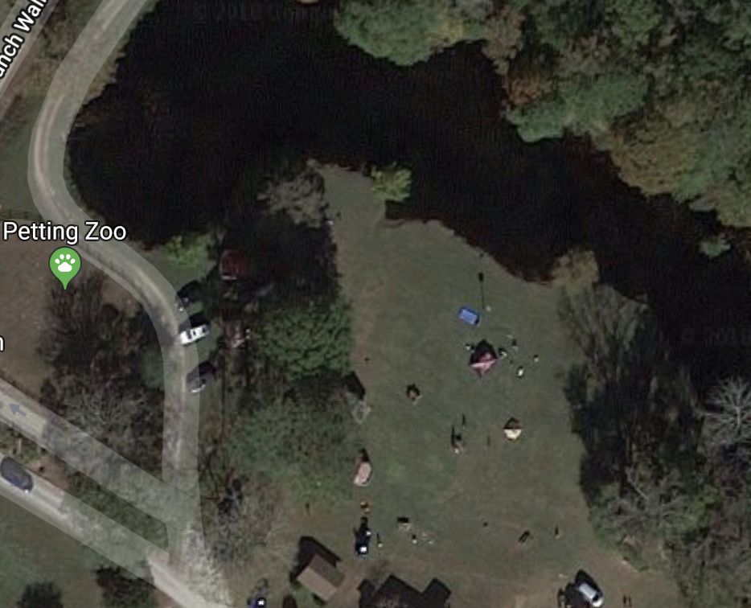
- At Triple R Ranch the rain site is the large open shelter. If the ceremony is occurring elsewhere designate an alternate location in case of rain.
Akela

Webelos

Ceremony Ring
Spec-tators

