www.pack901.com

Pack 901 Contacts
Kevin Tomb, Cubmaster
(C) 618-210-7323
kevintomb@hotmail.com

Mike Ferrara, Assistant Cubmaster
mike1926@gmail.com

Stephen Livingston, Committee Chairman
(W) 757-436-0111
steve@sdlcpapc.com

Meeting Information
Location
St. Thomas Episcopal Church
233 Mann Drive
Chesapeake, VA 23322
-Corner of Mann and Cedar Road
-3 blocks west of Battlefield Blvd S
Day and Time
Sundays at 5:00pm

St. Thomas Episcopal Church is our chartered organization. Church membership or attendance is not required. We bring together youth of every race, religion, ethnic background, and economic status in programs to develop character, citizenship, and fitness. Prejudice, intolerance and unlawful discrimination are unacceptable within the ranks of the Boy Scouts of America.
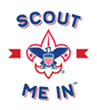
The Boy Scouts of America is the nation’s foremost youth program of character development and values-based leadership training for young women and young men.
Join the Scouting Fun
If it has been awhile since you’ve sung a song or done a silly skit just for the fun of it, you may need Scouting just as much as your child. Here’s a legitimate excuse to get away from the daily push and pull of life and just do fun stuff with your kids and like-minded adults.
Consider just how much time you get to spend with your kids after work, school, homework, sports, and friends take their bites out of the time available. For more information please visit: www.scouting.org/programs/cub-scouts/
Please contact us now to learn how you can help create your child’s future—starting right now www.pack901.com
Cub Scouts is just the beginning of the adventure! When your child reaches 6th grade he or she will cross over into Scouts BSA and work toward becoming an Eagle Scout. While your child can go to any Scouts BSA Troop he or she chooses, we are proud to be closely associated with Scouts BSA Troop 901 for boys and Troop 800 for girls, which also meet on Sundays.
Tidewater Council, Boy Scouts of America
1032 Heatherwood Drive
Virginia Beach VA 23455
757-497-2688 www.tidewaterbsa.com

Cub Scout

Pack 901

Helping Boys and Girls Create Their Future
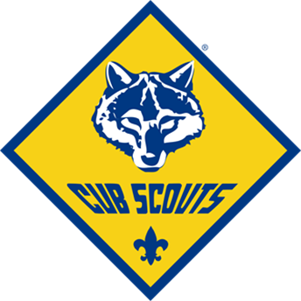
Check Out Our Year-Round Family-Oriented Program That Helps Kids Develop:
- Character
- Physical and Mental Fitness
- Citizenship Skills

5:00 PM Sundays
at
St. Thomas Episcopal Church

Cub Scouts is about family. Cub Scouts is about helping youth develop the confidence, self-esteem, and the life skills- like leadership and working in teams- they need to be successful.
JOIN PACK
Who We Are: Pack 901 is a Cub Scout unit for boys and girls, grades K-5th or 5-11 years old.
The Cub Scout motto is “Do Your Best!” The leaders and parents of Pack 901 do their best to make sure the youth learn from every experience and have fun. We are serious about the aims of Scouting and work to make sure each child grows in these areas. However, we have fun doing it! Lord Badin-Powell the founder of the Scouting Movement said…
“Scouting is a game with a purpose”
The leaders of Pack 901 are trained volunteers who are dedicated to a successful program for youth and the community at large. All Pack 901 adult leader applicants must complete BSA Youth Protection Training, have an annual criminal background check, and complete position specific training prior to being accepted as an adult Scout leader. Here’s the training our leaders must go through and stay current in based on BSA guidelines:
- Youth Protection Training
- Position Specific (Den leader, Cubmaster, Committee, etc.)
- Basic Leader Outdoor Orientation
What We Do: Cub Scouts is doing fun activities- 1 hour a week- with friends and family, learning new things, and being recognized for achievements. We do a series of carefully crafted activities in age or grade level specific “Dens” of multiple Cub Scouts which:
- Build confidence and fitness through physical activities for all ability levels
- Develop mental processes. Kids experiment, observe, reflect, calculate, and express ideas
- Develop a value system. Through learning, guided practice, and positive reinforcement, kids develop a sense of right and wrong, fair and unfair. Children learn from working with each other, and from adult role models
- Help kids learn to get along with others. Group activities provide the opportunity to learn how to balance give and take, accommodating others, and the value of teamwork
- Develop personal independence. Working with others outside their family builds confidence and helps prepare them to enter society
Cub Scouting Is Not Just For Boys.
Pack 901 is proud to offer the Cub Scout program for girls and boys!

These activities help develop the habits of success needed through the rest of their lives.
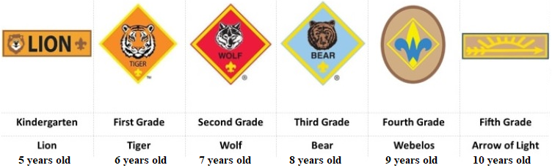

“The reputation of a thousand years may be determined by the conduct of just one hour” – Japanese proverb

What your kids do now creates the habits and thought patterns that will help them for the rest of their lives.
Ask any Cub Scout what they like about a Scouting and you will hear things like:
- We play fun games
- I like the other Scouts in my Den
- I like making stuff like Pinewood Derby cars, boats, rockets, and crafts
- I like doing new things with my family like camping, campfires, and hikes
- We do cool stuff like shoot bows and arrows, BB guns, and slingshots at summer camp
- I like earning patches and pins
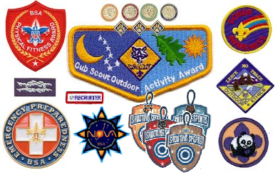

Here’s a list of typical activities Pack 901 Cub Scouts will do in a year:

- Complete a Cub Scout rank by doing a series of projects and activities with their Den or with family
- Do community service projects which help them learn about the environment and earn special awards like the World Conservation Award
- Build a pinewood car and compete in the Pinewood Derby race
- Camp with family at campouts
- Go on great outing: bicycle rodeos, hikes, STEM museums, and ball games
- Attend summer camps
- Sing songs and perform skits
- Create lifelong friends and memories

If you feel like you are on sidelines watching teachers, coaches, TV, internet, and video games have more influence over your child’s future than you, then Scouting with you kids may be the answer!

