New Scout Guide to Pack 374
Welcome to the Adventure of Cub Scouting

CUB SCOUT PACK 374
Tidewater Council
Princess Anne District

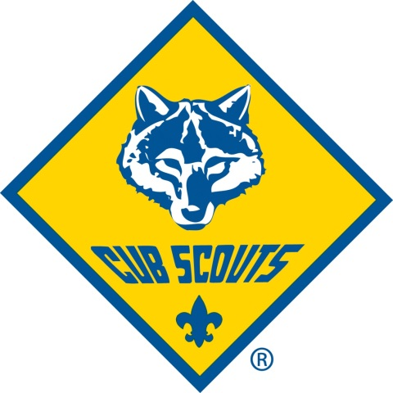
Where Character Counts and the Adventure Begins!
For Boys in Grades K–5

New Scout Guide Contents
Why Join Cub Scouting? 3
How Does Cub Scouting Work? 4
Dens 4
Pack 4
Pack Committee 4
Pack Communications 5
How is Pack 374 Funded? 5
How to Join Cub Scout Pack 374 5
What Forms are required? 5
What Uniforms are required? 5
How Can You Help? 5
Youth Protection 6
Contact Pack Leadership 6
Appendix A 7
Pack 374 - Financial Information 7
Appendix B 8
What Every Scout Learns First 8
Appendix C 9
A Word from the Tidewater Council 9

Why Join Cub Scouting?
The Cub Scout program helps to meet your boy's growth needs. As a boy develops, he has specific developmental needs such as:
- To learn new physical skills. He can do this through games, sports, and crafts. As he develops his coordination, he gains a sense of worthiness and acceptance by his peers.
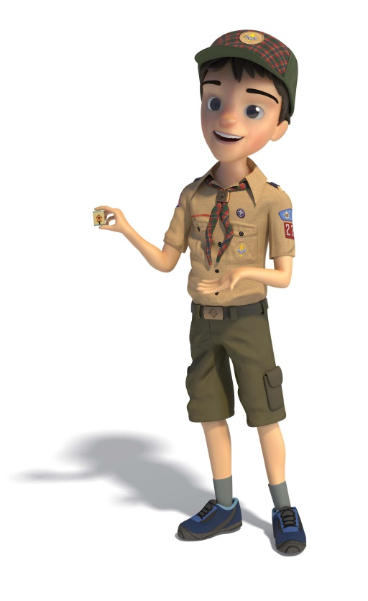
- To learn to get along with boys of his same age. He needs to form friendships with other boys. He needs to learn how to balance giving and receiving affection if he is to relate well to his peers. He needs to belong to a group of boys his own age. Being a part of a Cub Scout den helps fulfill these needs.

- To develop his mental processes. He can develop his mental process by reading, writing, and calculating. He needs opportunities to use language to express ideas and to influence others. He must move from a preoccupation with self to understanding how and what others think of him. Opportunities for observation and experimentation will help him learn self-reliance. Den activities and meetings, along with the advancement pro­ gram, help him develop mentally.

- To develop a value system. He is developing a sense of what is right and wrong and what is fair and unfair. He will do this by cooperating with other boys, by being taught, by examples of adults, and from positive reinforcement. He begins to develop democratic social attitudes.

- To develop personal independence. He is becoming less dependent on adults. His same age friends become important to him. In his den, and in the pack, he exercises his independence while learning to get along with others.

Your son also needs to belong to a "group" of boys his own age. This group is a key component of the Cub Scout program. A den is like a neighborhood group of six or eight boys in which he will achieve status and recognition.
As you learn more about how Cub Scouting works and what goes on in a den and a pack, you will see that the program helps your boy in these five important developmental needs. The uniqueness of Cub Scouting is that you, as his family, join the program with your boy. You will help him all along the way.
Scouting is fun with a purpose!

How Does Cub Scouting Work?
One unique thing about Cub Scouting is that you, as his family, join in on the program with your son, and you will help him along the way. The family is the basis of Cub Scouting. Boys have a different handbook at each grade level. As he advances through these books by working on activities with you, he will earn badges and other recognition that he can wear on his uniform.
The Cub Scouting program takes place at two levels. Your son will be a part of a Den; a small group of boys in the same grade level. Most Dens meet once or twice a month as scheduled by the Den Leaders. All dens, from grades K through 5, make up the Pack which meets at least once a month during the school year.

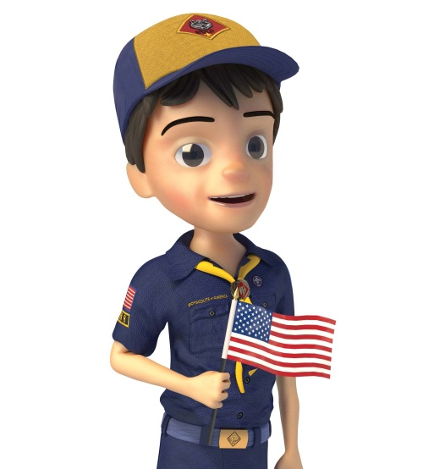
Dens
- The LION Den (Kindergarten)
  - Per BSA regulations, a parent or adult partner must accompany a Lion at all functions.
- The TIGER Den (Grade 1)
  - Per BSA regulations, a parent or adult partner must accompany a Tiger at all functions.
- The WOLF Den (Grade 2)
- The BEAR Den (Grade 3)
- The WEBELOS Den (Grade 4)
- The Arrow of Light (AOL) Den (Grade 5)

Pack
Cub Scout Pack 374 is made up of the dens, led by the Cubmaster, and typically meets at 6:00PM one weeknight per month at Christopher Farms Elementary School. This is the climax of the monthly den meetings and activities. There are games, skits, songs, ceremonies, and presentations of badges and awards that boys earned during that month. The pack, including families and siblings, also participates in other special events throughout the year, including:
- Pinewood Derby - Building and racing a model
- Blue and Gold Banquet - Cub Scouting’s birthday party
- Camping - Overnight and day camp opportunities introduce your family to the camping experience.
- Service Projects—Packs may participate in food drives, conservation projects, or other community activities.
- Field Trips and Special Outings—Great ways to learn more about the people and places in your community.

Pack Committee
Pack committee members are all volunteers and perform administrative functions of the pack. The committee meets monthly to discuss and plan pack activities, fundraising, leader training and advancement. All parent/adult partners are invited to attend pack committee meetings.

Pack Communications
Pack 374 utilizes the private website, SCOUTLANDER, for most communications. SCOUTLANDER allows all members of the pack to communicate through e-mail. All new pack members will receive an invitation to Pack 374s private site once youth application and registration fees are summited. As a pack member, you can update your contact info, find den and pack rosters, get leader contact information, access calendars for pack and den activities, get event details and RSVP as required. Training is provided on how to navigate SCOUTLANDER by your den leader or pack leadership.

How is Pack 374 Funded?
Pack 374 is funded primarily through the Cub Scout popcorn sale fundraiser and scouting dues. The popcorn fundraiser starts in August and concludes in early November. Details on the popcorn fundraiser and your scout’s dues are listed further in this guide. *NOTE: Lion Scouts do not participate in the fundraising/popcorn sales program.

How to Join Cub Scout Pack 374
Joining is now even easier! Go to https://beascout.scouting.org and register on-line or complete the youth application form and turn into any Pack 374 adult leader.

What Forms are required?
In addition to the online registration or paper registration form, pay the appropriate registration fees listed on Appendix A. All checks are payable to PACK374.
The Boy’s Life Magazine subscription is $12 per year. The subscription is not required but the boys really enjoy receiving and reading the magazine. The subscription can be combined with the youth application by checking the box on the application. Total registration with the subscription is $.
Prior to attending an overnight Cub Scout event, please turn in A/B of the BSA medical form. The doctor’s section, part 3, is not required. Forms can be found on BSA website, in Pack 374s orientation handouts, as well as on SCOUTLANDER under the forms folder.

What Uniforms are required?
Cub Scouts need a BSA Class-A Cub Scout shirt with the required patches, hat, slide, belt, and neckerchief. Pack 374 has custom hats at a cost of $15 that will negate the need to purchase new rank specific hats each year. The Tidewater Council Store can assist scouts in purchasing the correct uniform items; just provide your pack number 374 and your den number. Contact your den leader or refer to SCOUTLANDER for help. Pack 374 does not require BSA pants, shorts, or BSA socks although the Scouts are encouraged to wear them.
For some events, the scout can wear a Class-B pack t-shirt. Pack t-shirts are available for $15 at any monthly pack meeting or by contacting a member of the pack committee. *NOTE: Class-A uniforms are not required for Lion scouts. The pack t-shirt or Lions t-shirt is appropriate.

How Can You Help?
The most important help that you, as a parent/adult partner, can give your boy is to work with him on his Cub Scouting activities and ensure his attendance at Den and Pack meetings so you can celebrate his achievement. The den and the pack also rely on parent/adult partner participation to run a successful program. Cub Scouting operates through volunteer leadership. Consider volunteering as a member of the pack leadership team or as a parent/adult partner helper.
The Family Talent Survey Sheet (located in the New Scout Folder) is a great way to support your Cub Scout Pack. Den leaders are always busy with den activities. Our pack leaders and committee member know you have some talent that will help in the operation of our pack. Although your help may not be on a full-time basis, whatever you can do will be appreciated. Your pack committee wants to uncover ways you can enjoy giving assistance. Please return the form to any Pack Leader.
Your role as a parent/adult partner is the secret of success of the Cub Scouting program!

Youth Protection
Child abuse is a serious problem in our society, and unfortunately, it can occur anywhere, even in Scouting. Youth safety is of paramount importance to Scouting. For that reason, the BSA continues to create barriers to abuse beyond what have previously existed in Scouting.
Youth Protection training is required for all BSA registered volunteers.
We encourage all parent/adult partners to take the BSA’s Youth Protection training.
To find out more about the Youth Protection policies of the Boy Scouts of America and how to help Scouting keep your family safe, see the Parent’s Guide in any of the Cub Scouting or Boy Scouting handbooks, or go to http://www.scouting.org/Training/YouthProtection.aspx.

Contact Pack Leadership
Use Scoutlander to contact Cub Scout Pack 374 through the public page web address or email pack leadership with any of these email addresses

http://www.scoutlander.com/publicsite/unithome.aspx?UID=11767

- pack374committeechair@gmail.com
- p374cubmaster@gmail.com
- pack374recruiting@gmail.com

Appendix B

What Every Scout Learns First

The first award a new Cub Scout earns is the rank of Bobcat. The requirements are listed here; additional information on the requirements are found near the front of each Cub Scout handbook – Tiger, Wolf, Bear, WEBELOS.
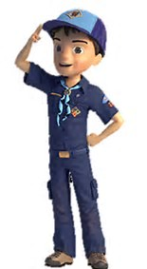
- Learn and say the SCOUT OATH, with help if needed.
On my honor, I will do my best
To do my duty to God and my Country and to obey the Scout Law;
To help other people at all times;
To keep myself physically strong, mentally awake, and morally straight.

- Learn and say the SCOUT LAW, with help if needed.
A Scout is:
Trustworthy, Loyal, Helpful, Friendly, Courteous, Kind,
Obedient, Cheerful, Thrifty, Brave, Clean, and Reverent.

- Show the CUB SCOUT SIGN. Tell what it means.
Make the sign with your right hand and with your arm held straight up. The two fingers stand for the Scout Oath and the Scout Law. They look like wolf’s ears ready to listen to Akela. Give the Cub Scout Sign when you say the Scout Oath or Scout Law.

- Show the CUB SCOUT HANDSHAKE. Tell what it means.
Using your right hand, place your fist two fingers along the inside of the other scout’s wrist. This means that you help each other remember and obey the Scout Oath and Law.

- Say the CUB SCOUT MOTTO.
Do Your Best

- Give the CUB SCOUT SALUTE. Tell what it means.
Point your first two fingers of your right hand out straight and close together. Touch the tip of the fingers to your cap or, if not wearing a cap, to your eyebrow. A salute is a way to show respect. When you salute a leader (either adult or other scout), you show him or her that you respect their position. When you salute the flag, you show that you are proud of your country.

- With your parent or adult partner, complete the exercises in the booklet How to Protect Your Children from Child Abuse. This booklet can be found in the front of the scout handbook.

Appendix C

A Word from the Tidewater Council

Welcome aboard! Your family is joining Cub Scouts and Tidewater Council, Boy Scouts of America is here to serve you. The council serves Norfolk, Portsmouth, Virginia Beach, and Chesapeake, as well as the seven northeastern counties of North Carolina.
Below are a few of the many service available to enhance your scouting experience.
To get you started -
- Tidewater Council Scout Shop is an official distributor of all official equipment and uniform needs of the Boy Scouts of America. The Scout Shop and offices are located at
1032 Heatherwood Drive
Virginia Beach, VA 23455

- To see the shop’s hours, go to http://tidewaterbsa.com and click on the SCOUT SHOP button on the top banner.
- Purchases at Tidewater Council Scout Shop are tax exempt.
- To be convenient for those who live a distance from the shop, shipping charges are only what the postage or UPS cost totals. There is NO service charge!
Have some fun -
- Pipsico Scout Reservation is YOUR camp, located on the James River in Surry County, VA. The camp covers more than 9—acres of land that was once owned by Captain John Smith!
- In addition to the activities in the pack, as your Cub Scout follows his “Adventure Trails,” the council offers camping and activities throughout the year.
Keep in the know –
- Visit Tidewater Council website at http://tidewaterbsa.com and click the JOIN button on the top banner.
- Subscribe to the “EK” Electronic Knapsack, a semi-monthly newsletter for Scouting families and leaders. Use the convenient link on the council website to subscribe.
- Take advantage of training (in person or online at http://my.scouting.org and in person classes can be found listed at heep://tidewaterbas.com/training-info/) and you will know what to expect for your Cub Scout.
Tidewater Council is here to serve you and make sure that your Scouting experience is the best it can be. If you have questions, feel free to call the council office at (757) 497-2688. The staff will connect you with the volunteer or staff member who is best able to assist you.

