

Scouting Programs

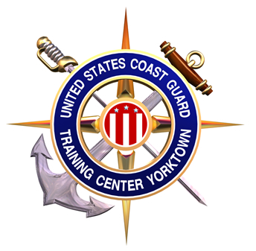
Training Center Yorktown is a U.S. Coast Guard Base and is located right next to the Yorktown National Park. Troops can camp at no cost, with the exception of breakfast in the galley.
Training Center Yorktown occupies the easternmost tip of Virginia's historical triangle, formed by Jamestown, Williamsburg, and Yorktown. In 1629, the Virginia Council issued an order calling for the settlement of the south bank of the Charles (now York) River. The following year, Governor Sir John Harvey was given a land patent of 752 acres at Wormley Creek establishing Yorke Village. Read more about our history at this link http://www.uscg.mil/tcyorktown/info/history.shtm

Services offered:
- Indoor pool (If available)
- Breakfast at the Galley for $2.10 per person
- Lunch & Dinner available for $4.25 per person
- Rest room facilities with showers
- Camping for one group of up to 50 persons (weekends only from April to October)
- Chapel services: Catholic-0945 Protestant-1100

How to reserve our site:
- E-mail (preferred) or call me to check availability at michael.f.mccarthy@uscg.mil or (757) 856-2346.
- Camp site is available from April to early October.
- I’ll need the following information:
- Troop number
- Dates requested
- Point of contact. (Name, Address, & Phone number)
- Estimated number of Scouts and Adult leaders.
- Troop must complete required paperwork 30 days prior to stay:
  - Sign a contract between the Troop and U.S. Coast Guard
  - Provide insurance certificate for $1 million and list Certificate Holder as “Training Center Yorktown, Yorktown, VA” (obtain this from Council)
  - Provide an alphabetized roster of attendees. Adults must provide photo ID upon arrival.

Training Center Yorktown does allow carefully controlled camp fires. All fires must be approvedby the Command Duty Officer before being started.

Links of interest:
http://www.uscg.mil/tcyorktown/index.shtm

http://cvcboyscouts.org/

http://www.bsacamps.org/

