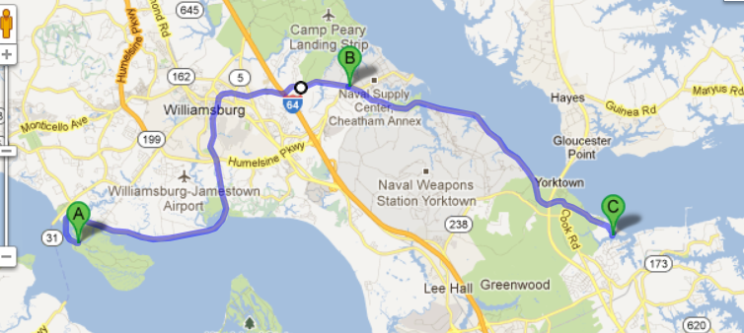

Point A: Jamestown Parking lot

Point B: Williamsburg Parking Lot

Point C: Gate to USCG Training Center Yorktown