Bike trip 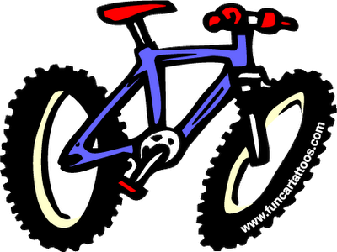 This year the bike trip is special because it is for everyone: bikers and none bikers. The bikers will do a bike ride for most of Saturday, while those that don’t want to ride will have fun by doing something at camp. The people who stay behind will cook and clean up for the bikers because the bikers will be tired when they come back. We also will need some adults to stay with the scouts that are staying behind.
The bike trip will be March 18 to March 20, 2011. It will be at Colonial Parkway. There will be two trips: One will be 30 miles and the other will be 12 miles. We will camp both nights at the USCG training Center in Yorktown, again.
The things you will need to do bring are: a bike in good condition (only for the bikers), your own lunch, helmet (only for the bikers), sleeping pad, tent, sleeping bag, swimming trunks and towel (for swimming later), class A uniform for both car rides and church on Sunday, personal gear, water bottle, small backpack fit for biking, and a bagged lunch for Saturday.
The cost will be this.
Breakfast= $2.30
Dinner (if no one stays behind to cook) $4.25
Saturday lunch= On bike trail BRING YOUR OWN
Gas money= $3.00

