Location:

Pipsico Scout Reservation

57 Pipsico Rd

Spring Grove, VA 23881

From Virginia Beach take 64W to 664W to Route 17N (toward the James River Bridge).  Near the JRB turn left on 258; 258 dead ends at Route 10. Turn right on R10 and follow the directions below to Pipsico once you pass the 7-11 in Surry.

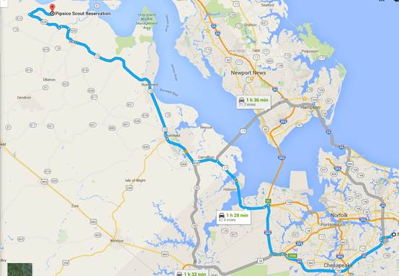

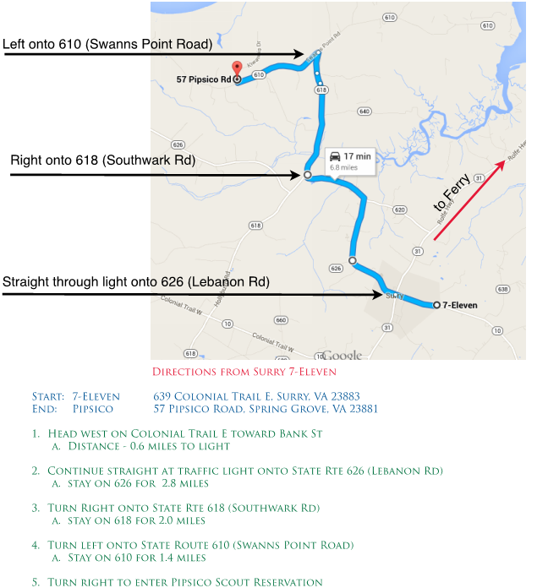

To get to Pipsico from the North or West follow directions at: http://pipsicobsa.com/resource-bank/